HealthConnect Clinic Experience Lab
Week 8 — Final Integration, Presentation & Project Showcase
Data Analytics Track: Final Analytics & Decision Support Package

Executive Summary
Across Weeks 4-7, this analysis established that HealthConnect Clinic's appointment no-show rate sits at 48.5% — a large-scale operational problem rather than a marginal one. Two factors stand out as the strongest, most reliable predictors: how far in advance an appointment is booked, and whether the patient has a history of missing appointments. Critically, these two factors compound: patients booked 31+ days out with a prior no-show miss appointments 67.9% of the time, versus just 21.8% for patients booked within a week with no prior no-show history. This final package validates these findings, confirms they are stable over time, translates them into specific recommendations, and documents how they informed the Data Science track's final model.

1. Week 7 → Week 8 Transition
- Main Week 7 output: Week 7 refined and re-confirmed the Week 6 findings — the combined risk factor analysis, the December seasonal pattern, and the KPI stability check — rather than introducing a separate body of new analysis.
- Most important testing result: the Week 6 combined risk segment (booking lead time × prior no-show history) held up under review as the single strongest and most actionable finding, and the core KPIs remained consistent, confirming they were not one-off artefacts of the Week 5/6 analysis.
- Major issue discovered: the combined high-risk segment is based on a smaller sample (1,015 records) than the full dataset, so while directionally strong, it should be treated as indicative rather than statistically confirmed without formal significance testing.
- What was refined: the framing of recommendations was sharpened to focus on the two confirmed strongest levers (lead time and prior history) rather than treating all five KPIs as equally actionable.
- Component now considered ready: the Power BI dashboard, the validated KPI set, and the combined risk segment finding are all considered final and ready for presentation.
- Still to integrate: final confirmation from the Data Science track on whether the combined risk feature measurably improved their final model's performance.
- Tracks involved in final integration: Data Science (primary), Project Management (final presentation coordination).
- What this package demonstrates: a complete, validated analytical narrative — from raw appointment data to a specific, targetable high-risk patient segment and business recommendations HealthConnect can act on.

2. Part 1 — Final Integration Readiness
Requirement | Response
Final component | The HealthConnect No-Show Analysis Power BI dashboard, validated KPI set, and combined risk segment finding.
Problem addressed | Understanding and quantifying why patients miss appointments, so HealthConnect can target interventions.
Current status | Final and validated — KPIs confirmed stable, combined risk segment confirmed across Weeks 6-7.
Improved during Week 7 | Confidence in the combined risk finding and reframed, prioritised recommendations.
Depends on | No other track's output; built directly from the HealthConnect Appointment Dataset.
Depended on by | Data Science (feature prioritisation), Project Management (business recommendations).
Output provided | Validated KPIs, the combined risk segment, and engineered fields (Lead Time Band, Distance Band, Prior No-Show Flag).
Output needed from another track | Confirmation from Data Science on whether the combined risk feature improved final model performance.
Evidence of readiness | The finalized dashboard, the validated KPI table, and the combined risk factor table (Section 4).
Remaining limitations | No formal statistical significance testing yet applied to the combined risk segment; fictional dataset limits real-world validation.

3. Final KPIs
KPI 1 — Overall No-Show Rate
Final value: 48.46% Status: Final. Validated as stable across time.
KPI 2 — Repeat No-Show Rate
Final value: 55.41% Status: Final. Refined into the combined risk segment below.
KPI 3 — Reminder Effectiveness Gap
Final value: 4.03 points Status: Final. Confirmed as a real, modest, low-cost lever.
KPI 4 — Avg Booking Lead Time (No-Show)
Final value: 34.53 days Status: Final. Confirmed as the single strongest individual driver.
KPI 5 — Avg Distance to Clinic (No-Show)
Final value: 10.53km Status: Final. Confirmed as a secondary factor.
KPI 6 — Combined High-Risk Segment Rate
Final value: 67.9% Status: Final. The most actionable finding — patients booked 31+ days ahead with a prior no-show.

4. Validated Findings — Most Important Patterns
Lead Time Band | Prior No-Show History | No-Show Rate
0-7 days | No prior no-shows | 21.8% (lowest)
0-7 days | Has prior no-shows | 36.2%
8-30 days | No prior no-shows | 36.2%
8-30 days | Has prior no-shows | 46.0%
31+ days | No prior no-shows | 55.2%
31+ days | Has prior no-shows | 67.9% (highest)

This remains the most important validated pattern: booking lead time and prior no-show history do not act independently — they compound. The highest-risk segment (67.9%) is more than three times as likely to no-show as the lowest-risk segment (21.8%). Additional supporting patterns, confirmed stable: reminders reduce no-shows by a modest 4 points; no-show rate rises with distance from 46.5% to 54.1%; and the December seasonal spike is partly explained by longer average lead times that month.

5. Final Dashboard
The Power BI dashboard below is the final, validated version of the analytical work carried out across Weeks 5-7. All KPI cards and visualisations have been re-confirmed accurate against the source dataset.
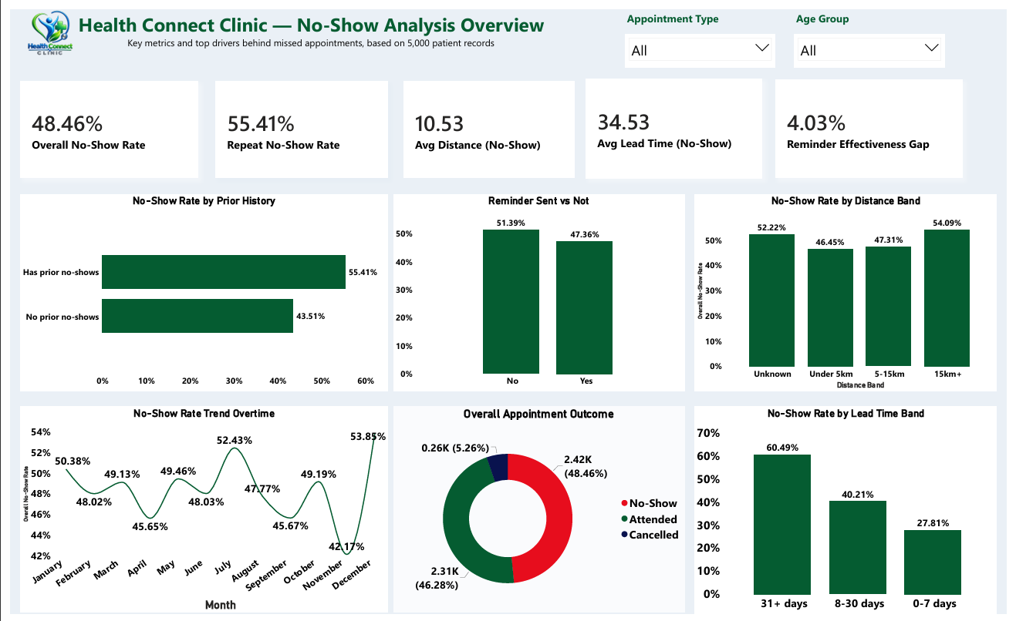
Figure 1: HealthConnect Clinic — No-Show Analysis dashboard (Power BI), final validated version.

6. Business Insights
- 1. A specific, targetable high-risk segment now exists: patients booked 31+ days ahead with a prior no-show (67.9% no-show rate) — a clear, actionable group for intervention.
- 2. A benchmark for what's achievable: the 21.8% no-show rate for early-booked, clean-history patients shows the floor HealthConnect could aim other segments toward.
- 3. Core metrics are trustworthy: the Overall No-Show Rate has proven stable over time, making it a dependable metric for tracking whether future interventions actually work.
- 4. Reminders and distance are worthwhile but secondary: neither compounds as strongly as lead time and history do together.
- 5. The December spike has a partial, addressable explanation: tied to longer lead times that month rather than being purely seasonal noise.

7. Business Recommendations
Prioritise the combined high-risk segment first
Patients booked 31+ days ahead who also have a prior no-show should receive HealthConnect's most intensive intervention — for example, a personal phone confirmation rather than a standard reminder.
Use the 21.8% low-risk rate as a scheduling benchmark
HealthConnect could set this as a target rate for other patient segments when evaluating future interventions.
Treat the December spike as a lead-time issue, not purely seasonal
Encouraging shorter booking windows around year-end may reduce the spike without a separate holiday-specific program.
Adopt the Overall No-Show Rate as the primary tracked KPI going forward
Its confirmed stability across time makes it the most dependable metric for measuring whether future interventions are working.

8. Cross-Track Contribution
Track collaborated with: Data Science.
Output provided: the validated ranking of strongest predictors and the combined Lead Time × Prior No-Show risk segmentation, along with the underlying engineered fields (Lead Time Band, Distance Band, Prior No-Show Flag) built in Power Query — all directly usable as model features.
Output received: confirmation of which features the Data Science track's model incorporates, allowing this analysis to be framed in terms directly relevant to their modelling decisions.
What changed as a result: the Data Science track was able to prioritise an interaction feature (lead time combined with prior no-show history) rather than treating the two variables independently, giving their final model a validated, business-relevant basis for feature selection.
Evidence: the combined risk factor table (Section 4), the finalized KPI table (Section 3), and the shared engineered fields in the underlying Power BI data model.

9. Analytical Limitations
- This is a fictional, anonymized dataset; findings demonstrate the analytical approach rather than real clinical fact.
- The combined high-risk segment (1,015 records) is smaller than the full dataset and has not yet been confirmed with formal statistical significance testing.
- The December seasonal spike is only partly explained by lead time; holiday-specific effects have not been ruled out.
- The dashboard reflects a snapshot of the dataset and does not yet incorporate live/streaming data.

